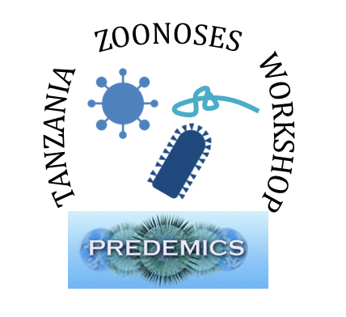

2nd February – 5th February 2016
Lake Manyara Serena Lodge, Tanzania

Biographies

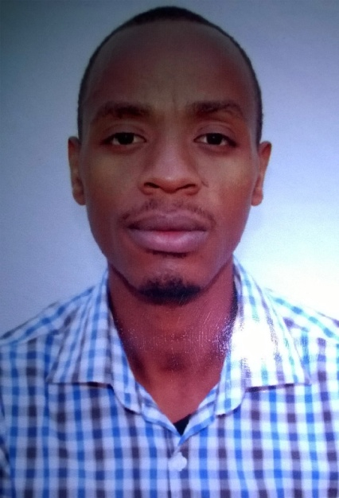 | Dennis K. Bahati is a Veterinarian currently working with the Colobus Conservation in promoting the conservation of primate species within the Diani Area, south coast Kenya. My interests are Animal Welfare and Wildlife Conservation. Also interested in zoonoses and its impact on the livelihood status of specific communities in Kenya especially the Maasai community. Therefore my diseases of interest are those that are common within these communities: Anthrax, Rabies, Foot and Mouth and Brucellosis.  At my current position, I am also very interested in Primate zoonotics that may include bacterial, viral, mycotic or parasitic infections.  Website: www.colobusconservation.org  Email: animalwelfare@colobusconservation.org
Jon Bielby is a Research Fellow at the Institute of Zoology, London. My research focuses on the factors that cause variation in the spread of infectious diseases, specifically those of wildlife species. In the past I have worked on the amphibian fungal disease chytridiomycosis, and have worked with Rosie Woodroffe and Christl Donnelly on factors affecting the spread of bovine tuberculosis in the UK. At present my research is focussed on understanding how co-infecting parasites and pathogen interact directly and via the host immune system to affect the spread of one or both infections.

Website: http://scholar.google.co.uk/citations?user=n8ADn6MAAAAJ
Email address: jon.bielby@ioz.ac.uk

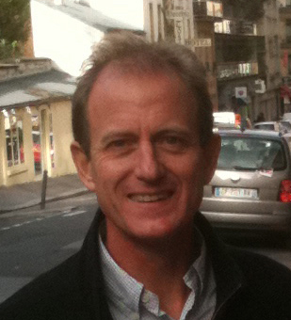 | Hervé Bourhy is head of the WHO Collaborating Centre for Reference and Research on Rabies at Institut Pasteur.  The main research objective of Hervé Bourhy is to study the biology and ecology of lyssavirus-host relationships. The aim is to approach the study of lyssavirus and host interplay from the level of dynamics of infection into the host population to the molecular mechanisms conditioning the early response of the cells to lyssavirus infection and the virulence of lyssaviruses in a new host species. This “integrative” approach offers the opportunity to understand the logic of molecular networks involved in the patho-biological process of lyssavirus infection. He has developed a large number of collaborations with African, Asian, European and other French laboratories working on similar subjects.  Website: https://research.pasteur.fr/en/team/lyssavirus-dynamics-and-host-adaptation/  Email address: herve.bourhy@pasteur.fr

Sam Bradd is a graphic facilitator and illustrator. He uses visuals to help groups increase engagement, solve problems, and lead. Together, it's Drawing Change. His background combines 15 years of facilitation experience, a Masters in Education, and a passion for helping organizations succeed. He's worked with Google, the World Health Organization, universities and governments.

Website: http://drawingchange.com/
Email: sam@sambradd.com

Sarah Cleaveland is a veterinary epidemiologist at the University of Glasgow (Institute for Biodiversity, Animal Health and Comparative Medicine) working on zoonotic and livestock diseases, with a focus on human-livestock-wildlife interface areas in East Africa. Her research aims to quantify disease burden, identify animal reservoirs of infection, understand risk factors for zoonotic diseases, and investigate multi-host infection dynamics in natural ecosystems. Her research interests include brucellosis, leptospirosis, Q-fever, Rift Valley Fever, trypanosomiasis, rabies, foot and mouth disease and malignant catarrhal fever. Cleaveland is also involved in several graduate training and capacity-strengthening initiatives with African partner institutions.
Website: www.gla.ac.uk/research/az/boydorr/
Website: http://livestocklivelihoodsandhealth.org
Email address: sarah.cleaveland@glasgow.ac.uk

Christl Donnelly is Professor of Statistical Epidemiology in the MRC Centre for Outbreak Analysis and Modelling, Department of Infectious Disease Epidemiology, Imperial College London, UK. I am the modelling workpackage leader for the EU Predemics project. I am particularly interested in understanding outbreak epidemiology and control. My background is biostatistics, but I have been collaborating with transmission modellers since joining Roy Anderson’s group back in 1995. Diseases of particular interest include: Ebola, MERS, SARS, influenza, bovine TB, rabies, foot-and-mouth disease, dengue, BSE/vCJD, malaria and HIV/AIDS. In addition to epidemiology and disease control, I am interested in conservation and animal welfare.

Website: http://www.imperial.ac.uk/people/c.donnelly
Email address: c.donnelly@imperial.ac.uk

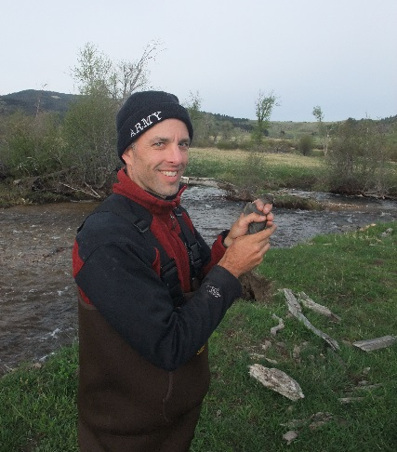 | Roarke Donnelly is an Associate Professor of Biology and Chair of the Urban Ecology Program at Oglethorpe University in Atlanta, USA. He is a field ecologist who studies birds and people to craft policies that promote native species conservation and public health, sometimes simultaneously in urban ecosystems. His recent research projects have investigated (1) species reintroduction techniques, (2) evolution of resistance to avian malaria in Hawaiian honeycreepers, and (3) the efficacy of ecotourism as a means to conserve biodiversity and increase standard of living. His ongoing administrative duties include conception and implementation of a public health minor.  Email address: rdonnelly@oglethorpe.edu
Anna Fahrion is a technical officer at the World Health Organization (WHO). I am a veterinarian with a background in veterinary parasitology and epidemiology. I graduated from University of Veterinary Medicine Hannover, and pursued my doctoral research at the Institute for Parasitology, University Zurich, followed by a Diplomate of the European College of Veterinary Public Health at University of Bern. Several research projects took me to Mali, Guinea, Northeast India, and Vietnam. I joined the WHO as a Junior Professional Officer, first working at the Division for Health Information and Evidence at the WHO Regional Office for Europe, and then changed to the Department of control of Neglected Tropical Diseases (NTD) at WHO headquarters, Geneva, in 2014. The focus of my current position is on country programmes, data collection and capacity building for zoonotic diseases such as Rabies, Taenia solium cysticercosis, and Echinococcosis.

Email: fahrionan@who.int

Tini Garske is a Research Fellow in the MRC Centre for Outbreak Analysis and Modelling, Department of Infectious Disease Epidemiology, Imperial College London, UK.
My work focuses on understanding infectious disease dynamics through mathematical and statistical modelling as well as outbreak analysis. I have experience in real-time outbreak analysis and am interested in vector borne diseases, in particular the influence of climate on transmission dynamics.
Much of my work has policy implications and is driven by the need to answer key questions of public health concern. I have worked on a wide range of different diseases, including Ebola, Yellow fever, Malaria, MERS, Pandemic and avian flu.

Website: http://www.imperial.ac.uk/people/t.garske
Email: t.garske@imperial.ac.uk

Delia Grace is a Program Manager in Food Safety Zoonoses at the International Livestock Research Institute.
She is an epidemiologist and veterinarian with 20 years experience in developing countries. She graduated from several leading universities and currently leads research on zoonoses and foodborne disease at the International Livestock Research Institute in Kenya and the CGIAR Research Program on Agriculture for Human Nutrition and Health. Her research interests include emerging diseases, participatory epidemiology, gender studies and animal welfare.

Her research program focuses on the design and promotion of risk-based approaches to food safety in livestock products in sub-Saharan Africa and South Asia. She is also a key player on ILRI’s Ecohealth/ One health approach to the control of zoonotic emerging infectious diseases project for Southeast Asia.

Website: http://aghealth.wordpress.com
Email: D.GRACE@cgiar.org

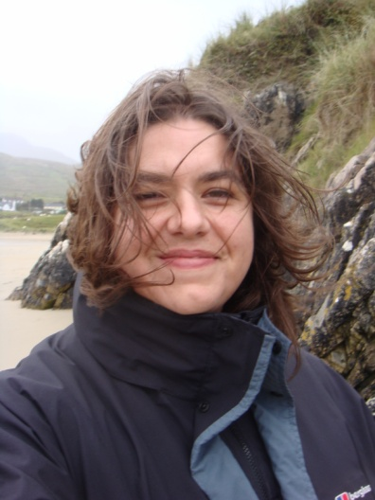 | Kate Jones is Professor of Ecology and Biodiversity at the Centre for Biodiversity and Environment Research at University College London, UK. I am a biodiversity modeller understanding the impacts of ecological and environmental change on the services provided by ecosystems, such as infectious zoonotic disease control. I am currently coPI on an ESPA project - Dynamic Drivers of Disease in Africa investigating a number of neglected tropical diseases (e.g., Lassa, Ebola, Henipah). I have a particular interest in bat evolution, ecology and conservation.  Website: http://www.katejones.org/  Email: kate.e.jones@ucl.ac.uk
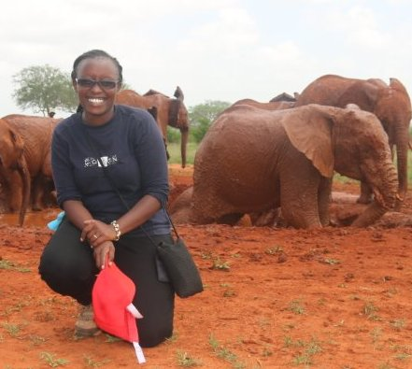 | Maryanne Kagai works for Africa network for Animal Welfare as an Animal Welfare officer. She is a registered veterinary surgeon with a passion for Animal Welfare. She is a hands-on professional who values working with communities to promote humane treatment of all animals. She has wide experience in organizing anti-rabies campaigns, spay neuter, De-snaring and rescues of wild animals with both local and international vets. She also runs a program in conjunction with the society for the protection of animals abroad (SPANA) of animal welfare clubs in primary schools to prepare the next generation of animal welfare ambassadors.  Website: www.anaw.org  Email: Maryanne@anaw.org

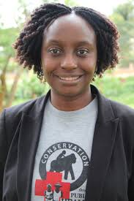 | Gladys Kalema-Zikusoka is Founder and Chief Executive Officer of a 12-year-old award winning NGO called Conservation Through Public Health (CTPH) that promotes biodiversity conservation by enabling people, wildlife and livestock to coexist through improving their health and livelihoods in and around protected areas in Africa. CTPH implements and champions “One Health” and conservation approaches, with field programs at Bwindi Impenetrable National Park - home to the critically endangered mountain gorillas, Queen Elizabeth National Park and started expanding to Virunga National Park in Democratic Republic of Congo (DRC) and Pian Upe Wildlife Reserve and Mount Elgon National Park in eastern Uganda.  Email: gladys@ctph.org
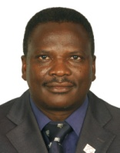 | Julius Keyyu is a Director of Research at the Tanzania Wildlife Research Institute (TAWIRI) in Tanzania. Dr. Keyyu holds a PhD in disease ecology with specialization in ecosystem and population health. His research work is mainly on diseases at the wildlife-livestock-human interface especially zoonotic diseases. Diseases of particular interest include Rift Valley Fever, bovine TB, Brucellosis, influenza, foot-and-mouth disease and helminthosis. In addition to disease ecology and disease control, Dr. Keyyu works on conservation of biological diversity at large and biological resources. Dr. Keyyu is a National Focal Point on Wildlife in Tanzania for the World Organisation for Animal Health (OIE).  Website: http://www.tawiri.or.tz  Email: julius.keyyu@gmail.com
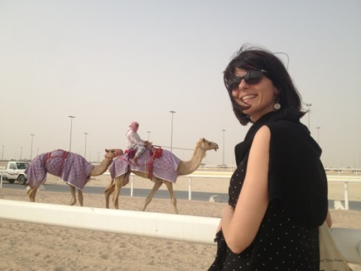 | Eve Miguel is a researcher in eco-epidemiology at the University of Montpellier. My research is mainly focused on pathogen spillover at the wild / domestic / human interface. I am particularly interested on animal / human behaviors which lead to disease epidemics. I am trying to depict spatial interactions among species and seasonal patterns to understand the epidemiology of the disease.  My background is ecology and evolution but I have been collaborating with veterinary, wildlife manager, decision makers, modelers, epidemiologist and sociologist.  Diseases of particular interest for me include : Foot and Mouth Disease, bovine Tuberculosis, MERS- Corona-virus, Tick diseases (Theileriosis), Malaria, Rift Valley Fever  I am also interested in human well-being and animal conservation in southern countries and by scientific popularization in particularly for young people  Website: www.evemiguelblog.wordpress.com;  www.researchgate.net/profile/Eve_Miguel  Email address: eve.miguel@ird.fr / eve.miguel@cirad.fr

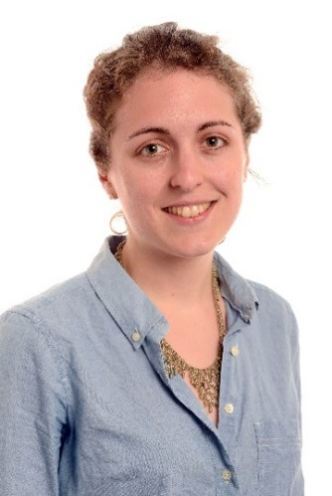 | Harriet Mills is a postdoctoral research associate in the MRC Centre for Outbreak Analysis and Modelling, Department of Infectious Disease Epidemiology, Imperial College London, UK.  I am interested in analysing outbreaks to understand patterns of transmission and human interactions which lead to epidemics. Diseases of particular interest to me include Ebola, influenza, MERS Corona virus, HIV and tuberculosis. I am also interested in public engagement, in particular in encouraging girls to study science and exploring gender bias in science.  Website: www.harrietlmills.co.uk; www.imperial.ac.uk/people/h.mills  Email address: h.mills@imperial.ac.uk
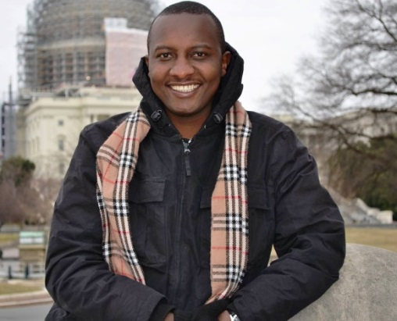 | Matthew Muturi is an epidemiologist at the Kenya Zoonotic Disease Unit: a One Health (OH) office formed between the Kenya Ministries of Health and Agriculture. My training is in veterinary medicine and epidemiology. My interests are in neglected zoonotic disease research with focus on disease modelling. At present I am researching on brucellosis in pastoral communities of Kenya.  Email: muturimathew@gmail.com  Website: www.zdukenya.org
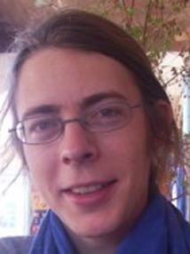 | Pierre Nouvellet is a Lecturer in Infectious Disease Modelling in the MRC Centre for Outbreak Analysis and Modelling, Department of Infectious Disease Epidemiology, Imperial College London, UK.  My background is in ecology and my research interests broadly lie between epidemiology, ecology and statistical inference. I am particularly interested in the modelling of zoonotic diseases, from endemic (rabies, bovine TB) to emerging ones (Ebola, MERS-cov). In this context, I am involved in developing transmission models to gain biological and epidemiological insights and to inform risk assessment and contingency planning. In addition, I am also interested in modelling population dynamics and animal movement.  Website: http://www.imperial.ac.uk/people/p.nouvellet  Email: p.nouvellet@imperial.ac.uk

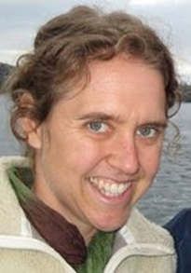 | Sarah Olson is Associate Director of Wildlife Epidemiology for the Wildlife Conservation Society’s Wildlife Health & Health Policy Program. I provide leadership and research support to field veterinarians and staff. My research aims to understand the impact of disease associated with development on humans and wildlife. I work on a range of health issues linked to conservation including the wildlife trade and emerging infectious diseases, malaria, Ebola virus disease in great apes, avian influenza and white-nose syndrome in North American bats.  Website: www.wcs.org  Email address: solson@wcs.org
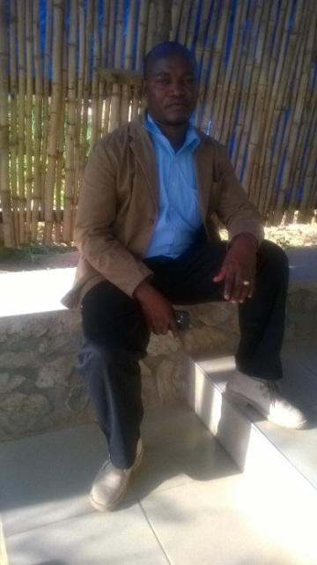 | Goodluck Paul is a Doctor of Veterinary Medicine and Public Health with the Health for Animals and Livelihood Improvement (HALI) Project, Sokoine University of Agriculture (SUA), Tanzania. He gained experience when completing research activities, titled prevalence and Molecular Epidemiology of Mycobacterium bovis and M. tuberculosis in slaughterhouses studies. He is interested to understand the Epidemiology and transmission dynamics of M. bovis at the human-animal-environment interface in rural Tanzania. In addition to Epidemiology of Tuberculosis, He is interested on the Epidemiology of Rift Valley Fever, Brucellosis and other bacterial and viral zoonoses of public health importance.  Email address: goodlukp6@gmail.com
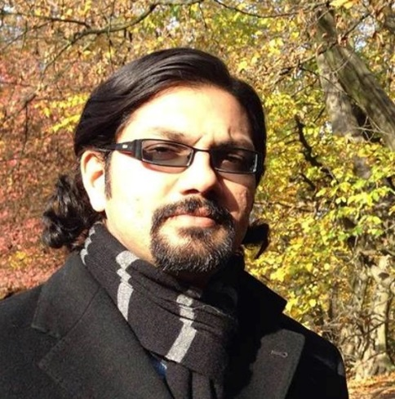 | Sreejith Radhakrishnan is a veterinarian from India, based at the Department of Infectious Disease Epidemiology (DIDE), Imperial College London, UK as Visiting Researcher. After completing a Masters in Wild Animal Health at the Royal Veterinary College, London, I worked for six years in India as a field veterinarian in the Kerala state Departments of Animal Husbandry and Forests and Wildlife. I also taught wildlife studies at the Kerala Veterinary and Animal Sciences University. I have a keen interest in studying the epidemiology of zoonotic infectious diseases, particularly rabies, in relation to the development of strategies for their control and eradication in India and other low and middle-income countries. At DIDE, I am involved in a project to analyse the epidemiology of rabies in the Russian Federation using data from the website of the WHO’s European Rabies Bulletin. I plan to pursue a PhD researching the epidemiology of rabies in free-ranging dogs in India. I am also interested in the links between health, poverty and social justice.  Personal blog: www.shrekatrandomhouse.blogspot.co.uk  Email address: s.radhakrishnan14@imperial.ac.uk

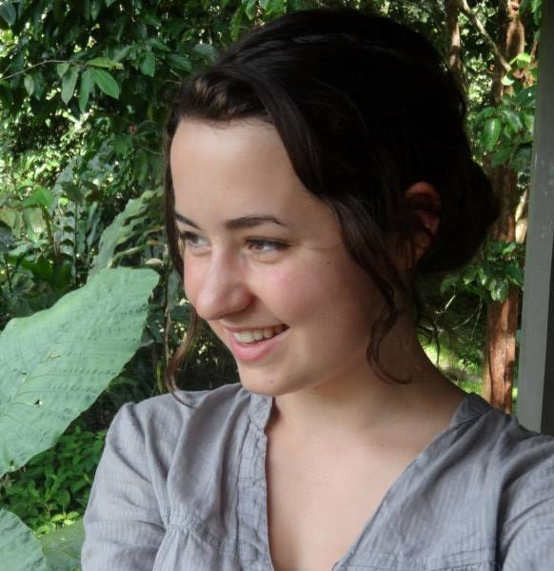 | Isobel Routledge is a MRes student at the Department of Infectious Disease Epidemiology, Imperial College London, UK. I am in the first year of a Wellcome Trust Four Year PhD programme in Epidemiology, Evolution, and Control of Infectious Disease, with an interest in infectious disease ecology, public health and policy. My background is in biology (mainly ecology and evolution), however through my PhD I am looking to gain skills in modeling and/or biostatistics, ideally in close collaboration with field researchers/collecting empirical data myself. I am interested in model-guided fieldwork, and how modellers, statisticians, ecologists and clinicians/public health professionals can collaborate effectively. I am generally interested in zoonotic and vector borne diseases, and how social and environmental factors such as the built environment, land use change and climate affect their dynamics.  Email: i.routledge15@imperial.ac.uk
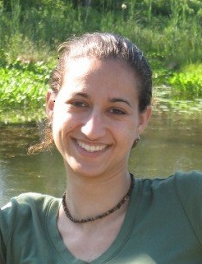 | Ilana Schafer is a veterinary epidemiologist at the U.S. Centers for Disease Control and Prevention. She has worked on public health responses and epidemiologic investigations of Ebola and other high hazard zoonotic viruses such as Marburg virus, Nipah virus, and lymphocytic choriomeningitis virus, including participation in five Ebola and Marburg viral disease outbreak responses. Ilana was the project lead and designer of the Epi Info Viral Hemorrhagic Fever (VHF) Application – software that has been used throughout West Africa since 2014 for Ebola outbreak data management. She has recently switched her focus to the epidemiology of leptospirosis and other bacterial zoonoses.  Email: wii3@cdc.gov
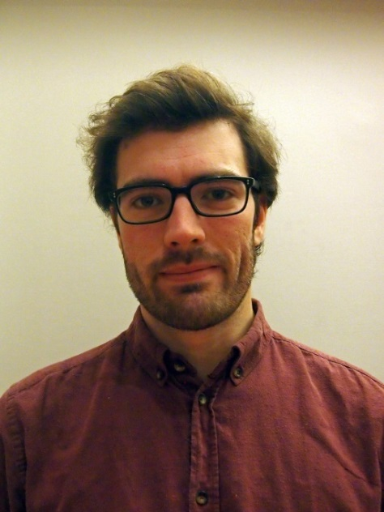 | Tom Smallwood is a PhD candidate at the Department of Infectious Disease Epidemiology, Imperial College London and Institute of Zoology, ZSL under the Science and Solution for a Changing Planet DTP. My research is on modelling multi-host viral diseases for biodiversity conservation, with particular focus on two case studies: rabies in African wild dogs and Ebola in non-human great apes. My background is as an ecologist, previously modelling the thermal sensitivity of disease vector population dynamics during my masters. In addition to the diseases and species specified by the case studies I am interested in the range of other multi-host diseases and affected wildlife.  Website: www.thomasrcsmallwood.com  Email: thomas.smallwood14@imperial.ac.uk

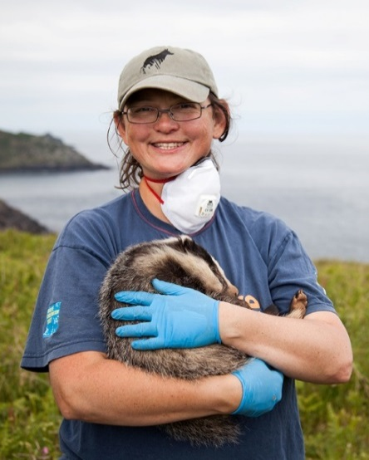 | Rosie Woodroffe is a Senior Research Fellow at the Institute of Zoology in London and an Honorary Professor in the Department of Infectious Disease Epidemiology at Imperial College London, UK. I am a field ecologist focusing on the coexistence of people and wildlife, including pathogen transmission between wild and domestic animals as well as broader conservation issues. One of my main study systems concerns Mycobacterium bovis transmission between badgers and cattle in Britain. Another concerns the coexistence of endangered African wild dogs with people, including managing rabies transmission from domestic dogs.  Website: https://www.zsl.org/users/rosie-woodroffe  Email: rosie.woodroffe@ioz.ac.uk  Twitter: @rosiewoodroffe

